**QS3:** STAR LAWS (Shedding Light on Astronomy) Episode III:  **Why do we have Seasons?**Name: __________________________________

1. The hottest season is _________________ and the coldest season is __________________. ________________ follows summer and is characterised by falling temperatures. ________________ follows winter and is characterized by _______________ temperatures.
2. The angle of Earth’s axis of rotation with respect to the orbital plane is _______________.
3. Use the diagram at right to explain why the Southern Hemisphere experiences summer and the Northern Hemisphere experiences winter when it is in the position shown.

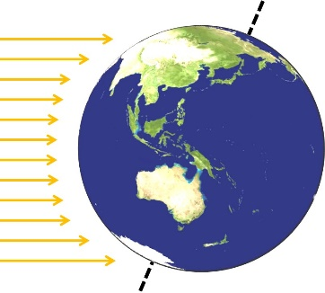

(a)

(b)

(c)

(d)

**sunlight**

____________________________________

____________________________________ ____________________________________

____________________________________

__________________________________________________________________________________________

__________________________________________________________________________________________

1. Regions of the Earth near the equator don’t experience seasons in quite the same way as the rest of the planet. Why is it warm to hot near the equator all year round? ______________________________________________  
   ____________________________________________________________________________________________________________________________________________________________________________________
2. Label the dotted lines (a) and (c) on the diagram above. (The answers to (b) and (d) are given later in the video.)
3. 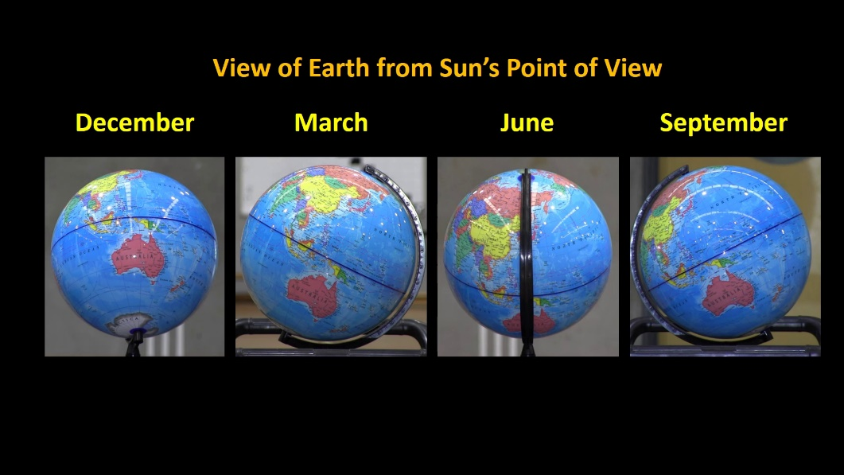The images below show how the Earth appears from the Sun’s point of view in the months of…  
    ______________, ______________, _____________, and ____________.
4. On around ____________________every year, the December solstice occurs. It is often called the _______________________ solstice in the southern hemisphere and the _______________________ solstice in the northern hemisphere. On this day, the sun is directly over the ___________________________________.

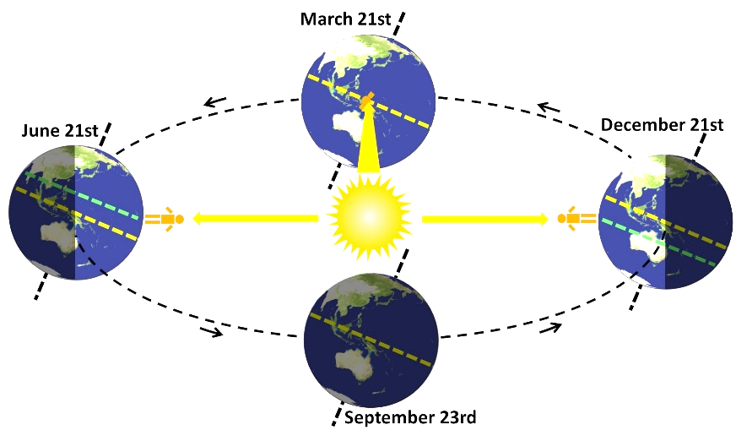

The nights in the southern hemisphere are __________ and the days are ___________.

In the northern hemisphere, the nights are __________ and the days are ___________.

1. On around __________________ every year, the June solstice occurs. It is often called the _________________ solstice in the southern hemisphere and the ________________ solstice in the northern hemisphere. On this day, the sun is directly over the _____________________________________.
2. On around March 21st and September 23rd every year, the two ____________________ occur. The sun is directly over the ___________________. Daytime lasts approximately ___________ hours and night time also lasts about ___________ hours.
3. Label dotted lines (b) and (d) on the diagram above next to Q3.
4. When it’s summer in the southern hemisphere, it’s _____________________ in the northern hemisphere.